**EXPERIMENT NUMBER- 16**

**AIM**

* Write a Javascript Program to display table to order Pizza.

**DESCRIPTION**

* JavaScript is a very powerful client-side scripting language. Javascript enhance the interaction between user and web page. You can make your webpage livelier and more interactive, with  
  the help of JavaScript.
* Table and Form tags are used to make the basic structure of the required table. We use the input tags to take the quantities of each Pizza in the order.
* Onclick() is used to execute an event associated with click of the mouse.

**PROGRAM(S)**

**HTML File**

<!DOCTYPE html>

<html>

<head>

<title>Pizza Order</title>

<script src = "6-1-2.js"></script>

<style>

body{

background-image: url(https://thumbs.dreamstime.com/z/pizza-background-white-wooden-table-top-view-free-space-your-text-rustic-style-pizza-background-white-wooden-table-168103854.jpg)

}

</style>

</head>

<body>

<form>

<h3 align = "center">Pizza Order Form</h3>

<table border = "2" align = "center" bgcolor = "black" style = "color:white">

<tr>

<th>Item Name</th>

<th>Price</th>

<th>Ouantity</th>

</tr>

<tr>

<td>Chicken Pizza</td>

<td>100</td>

<td><input type = "text" id = "P1"/></td>

</tr>

<tr>

<td>Paneer Pizza</td>

<td>80</td>

<td><input type = "text" id = "P2"/></td>

</tr>

<tr>

<td>Veg Pizza</td>

<td>70</td>

<td><input type = "text" id = "P3"/></td>

</tr>

</table>

<center>

<p>

<input type="button" value="totalcost"

onclick="computetotal();"/>

<input type="text" size="5" id="cost"

onfocus="this.blur();"/>

</p>

<input type="submit" value="confirm order"

onclick="confirmorder();"/>

<input type="reset" value="Cancel order"/>

</center>

</form>

</body>

</html>

**JS File**

function computetotal()

{

var cpizza= document.getElementById("P1").value;

var ppizza=document.getElementById("P2").value;

var vpizza=document.getElementById("P3").value;

document.getElementById("cost").value=cpizza*100+ppizza*80+vpizza*70;

}

function confirmorder()

{

confirm("your order is confirmed reach you in 10 minutes");

}

**RESULTS/OUTPUT**

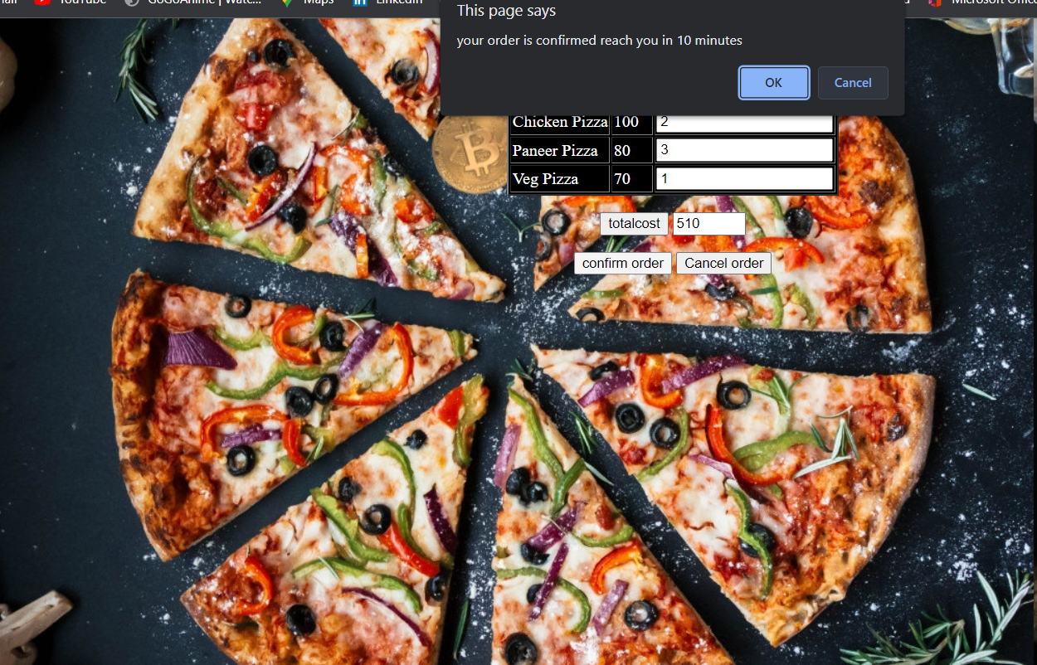

**EXPERIMENT NUMBER- 17**

**AIM**

* Write a Javascript Program to design a calculator.

**DESCRIPTION**

* JavaScript is a very powerful client-side scripting language. Javascript enhance the interaction between user and web page. You can make your webpage livelier and more interactive, with  
  the help of JavaScript.
* Form tag is used to make the basic layout of the calculator which includes the display and the buttons corresponding to different inputs and operations. We use the input tags to take the data for performing the arithmetic operations.
* The <div> tag defines a division or a section in an HTML document. The <div> tag is used as a container for HTML elements - which is then styled with CSS or manipulated with JavaScript. The <div> tag is easily styled by using the class or id attribute. Any sort of content can be put inside the <div> tag!

**PROGRAM(S)**

**Html file**

<!DOCTYPE html>

<html>

<head>

<title>

Calculator Program in JavaScript

</title>

<script type="text/javascript" src="task6.js">

</script>

<link rel="stylesheet" href="task6.css">

</head>

<body>

<div class= "formstyle">

<form name = "form1">

<input class= "textview" name = "textview">

</form>

<center>

<div class="a">

<table>

<tr>

<tr>

<td> <input class = "btn" type = "button" value = "1" onclick = "insert(1)" > </td>

<td> <input class = "btn" type = "button" value = "2" onclick = "insert(2)" > </td>

<td> <input class = "btn" type = "button" value = "3" onclick = "insert(3)" > </td>

<td> <input class = "btn" type = "button" value = "+" onclick = "insert('+')" > </td>

</tr>

<tr>

<td> <input class = "btn" type = "button" value = "4" onclick = "insert(4)" > </td>

<td> <input class = "btn" type = "button" value = "5" onclick = "insert(5)" > </td>

<td> <input class = "btn" type = "button" value = "6" onclick = "insert(6)" > </td>

<td> <input class = "btn" type = "button" value = "-" onclick = "insert('-')" > </td>

</tr>

<tr>

<td> <input class = "btn" type = "button" value = "7" onclick = "insert(7)" > </td>

<td> <input class = "btn" type = "button" value = "8" onclick = "insert(8)" > </td>

<td> <input class = "btn" type = "button" value = "9" onclick = "insert(9)" > </td>

<td> <input class = "btn" type = "button" value = "*" onclick = "insert('*')" > </td>

</tr>

<tr>

<td> <input class = "btn" type = "button" value = "C" onclick = "form1.textview.value = ' ' " > </td>

<td ><input class = "btn"type = "button" value = "0" onclick = "insert(0)" > </td>

<td> <input class = "btn"type = "button" value = "=" onclick = "equal()"> </td>

<td> <input class = "btn" type = "button" value = "/" onclick = "insert('/')" > </td>

</tr>

</tr>

</table>

</div>

</center>

</div>

</body>

</html>

**CSS File**

.formstyle

{

width: 250px;

height: 270px;

margin: 20px auto;

border: 3px solid black;

border-width: thick;

border-radius: 5px;

padding: 20px;

text-align: center;

background-color: white;

}

.a{

border:2px solid black;

width:240px;

}

*{

margin: 0;

padding: 0;

}

.btn{

width: 50px;

height: 50px;

font-size: 25px;

margin: 2px;

cursor: pointer;

color: black;

}

.textview{

width: 223px;

margin: 5px;

font-size: 25px;

padding: 5px;

background-color: white;

border: 3px solid black;

border-style:double;

border-width:thick;

}

JS File

function insert(num)

{

document.form1.textview.value = document.form1.textview.value + num;

}

function equal()

{

var exp = document.form1.textview.value;

if(exp)

{

document.form1.textview.value = eval(exp)

}

}

function backspace()

{

var exp = document.form1.textview.value;

document.form1.textview.value = exp.substring(0, exp.length - 1);

}

**RESULTS/OUTPUT**

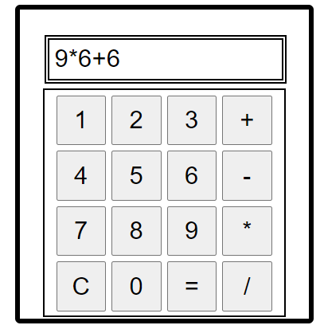 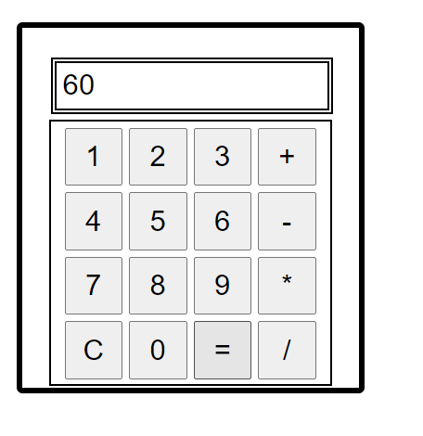

**EXPERIMENT NUMBER- 18**

**AIM**

* Write a Javascript Program to handle mouse events.

**DESCRIPTION**

* JavaScript is a very powerful client-side scripting language. Javascript enhance the interaction between user and web page. You can make your webpage livelier and more interactive, with  
  the help of JavaScript.
* The change in the state of an object is known as an **Event**. In html, there are various events which represents that some activity is performed by the user or by the browser. When javascript code is included in html, js react over these events and allow the execution. This process of reacting over the events is called **Event Handling**. Thus, js handles the HTML events via **Event Handlers**.
* Mouse handling events include – click, mouseover, mouseout, mousedown, mouseup, mousemove, etc.

**PROGRAM(S)**

<!DOCTYPE html>

<html>

<head>

<title>Mouse Handling Events</title>

<script>

function bigImg(x) {

x.style.height = "256px";

x.style.width = "256px";

}

function normalImg(x) {

x.style.height = "128px";

x.style.width = "128px";

}

function mouseDown() {

document.getElementById("sai").style.color = "red";

}

function mouseUp() {

document.getElementById("sai").style.color = "green";

}

</script>

</head>

<body>

<p>Onclick() - </p>

<button type = "button" onclick="this.innerHTML = 'Hi!!'">Click here!</button>

<p>Onmouseover() & Onmouseout() - </p>

<img onmouseover="bigImg(this)" onmouseout="normalImg(this)" src="pic1.jpg" alt="Scenary" width="20%" height="20%">

<p>Onmouseup() and Onmousedown()</p>

<p id = "sai" onmouseup="mouseUp()" onmousedown="mouseDown()">Click the text!</p>

</body>

</html>

**RESULTS/OUTPUT**

